DishUp: MVP Testing, Round 2
Aaron Shaw · IS 581 · dishup-mvp.vercel.app
What I Changed After Round 1
I updated the prototype to fix every problem my Round 1 testers ran into:
Round 1 finding | Change I made
Only 8 of 20 searches were useful. "tacos", "indian food" and "korean bbq" returned nothing | Search now handles plurals, phrases and cuisine words, suggests fixes for typos ("Did you mean pizza?") and offers cuisines when nothing matches
Testers couldn't see their review after posting | The page scrolls to the new review and highlights it as "Your review"
No address or hours ("where is it and is it open?") | Every restaurant shows its address and a "Directions & hours" Google Maps link
"Rate a dish" was 3 screens down on phones | A "Rate a dish here" button stays at the bottom of the screen on phones
Phone friction: "Click or drag" photo box and a repeated banner photo | The photo box says "Tap to add a photo" on phones, and the banner no longer repeats the first dish
MVP
DishUp lets people rate a specific dish at a restaurant, not the whole restaurant. The prototype is a live website with 9 real Provo/Orem restaurants and 34 menu items. Users can search, filter by location and rating, view dish photos and reviews, get directions, and post a review with stars, text and a photo. It's styled like OpenTable, works on phones and loads in under a second, so testers react to the idea rather than rough edges.
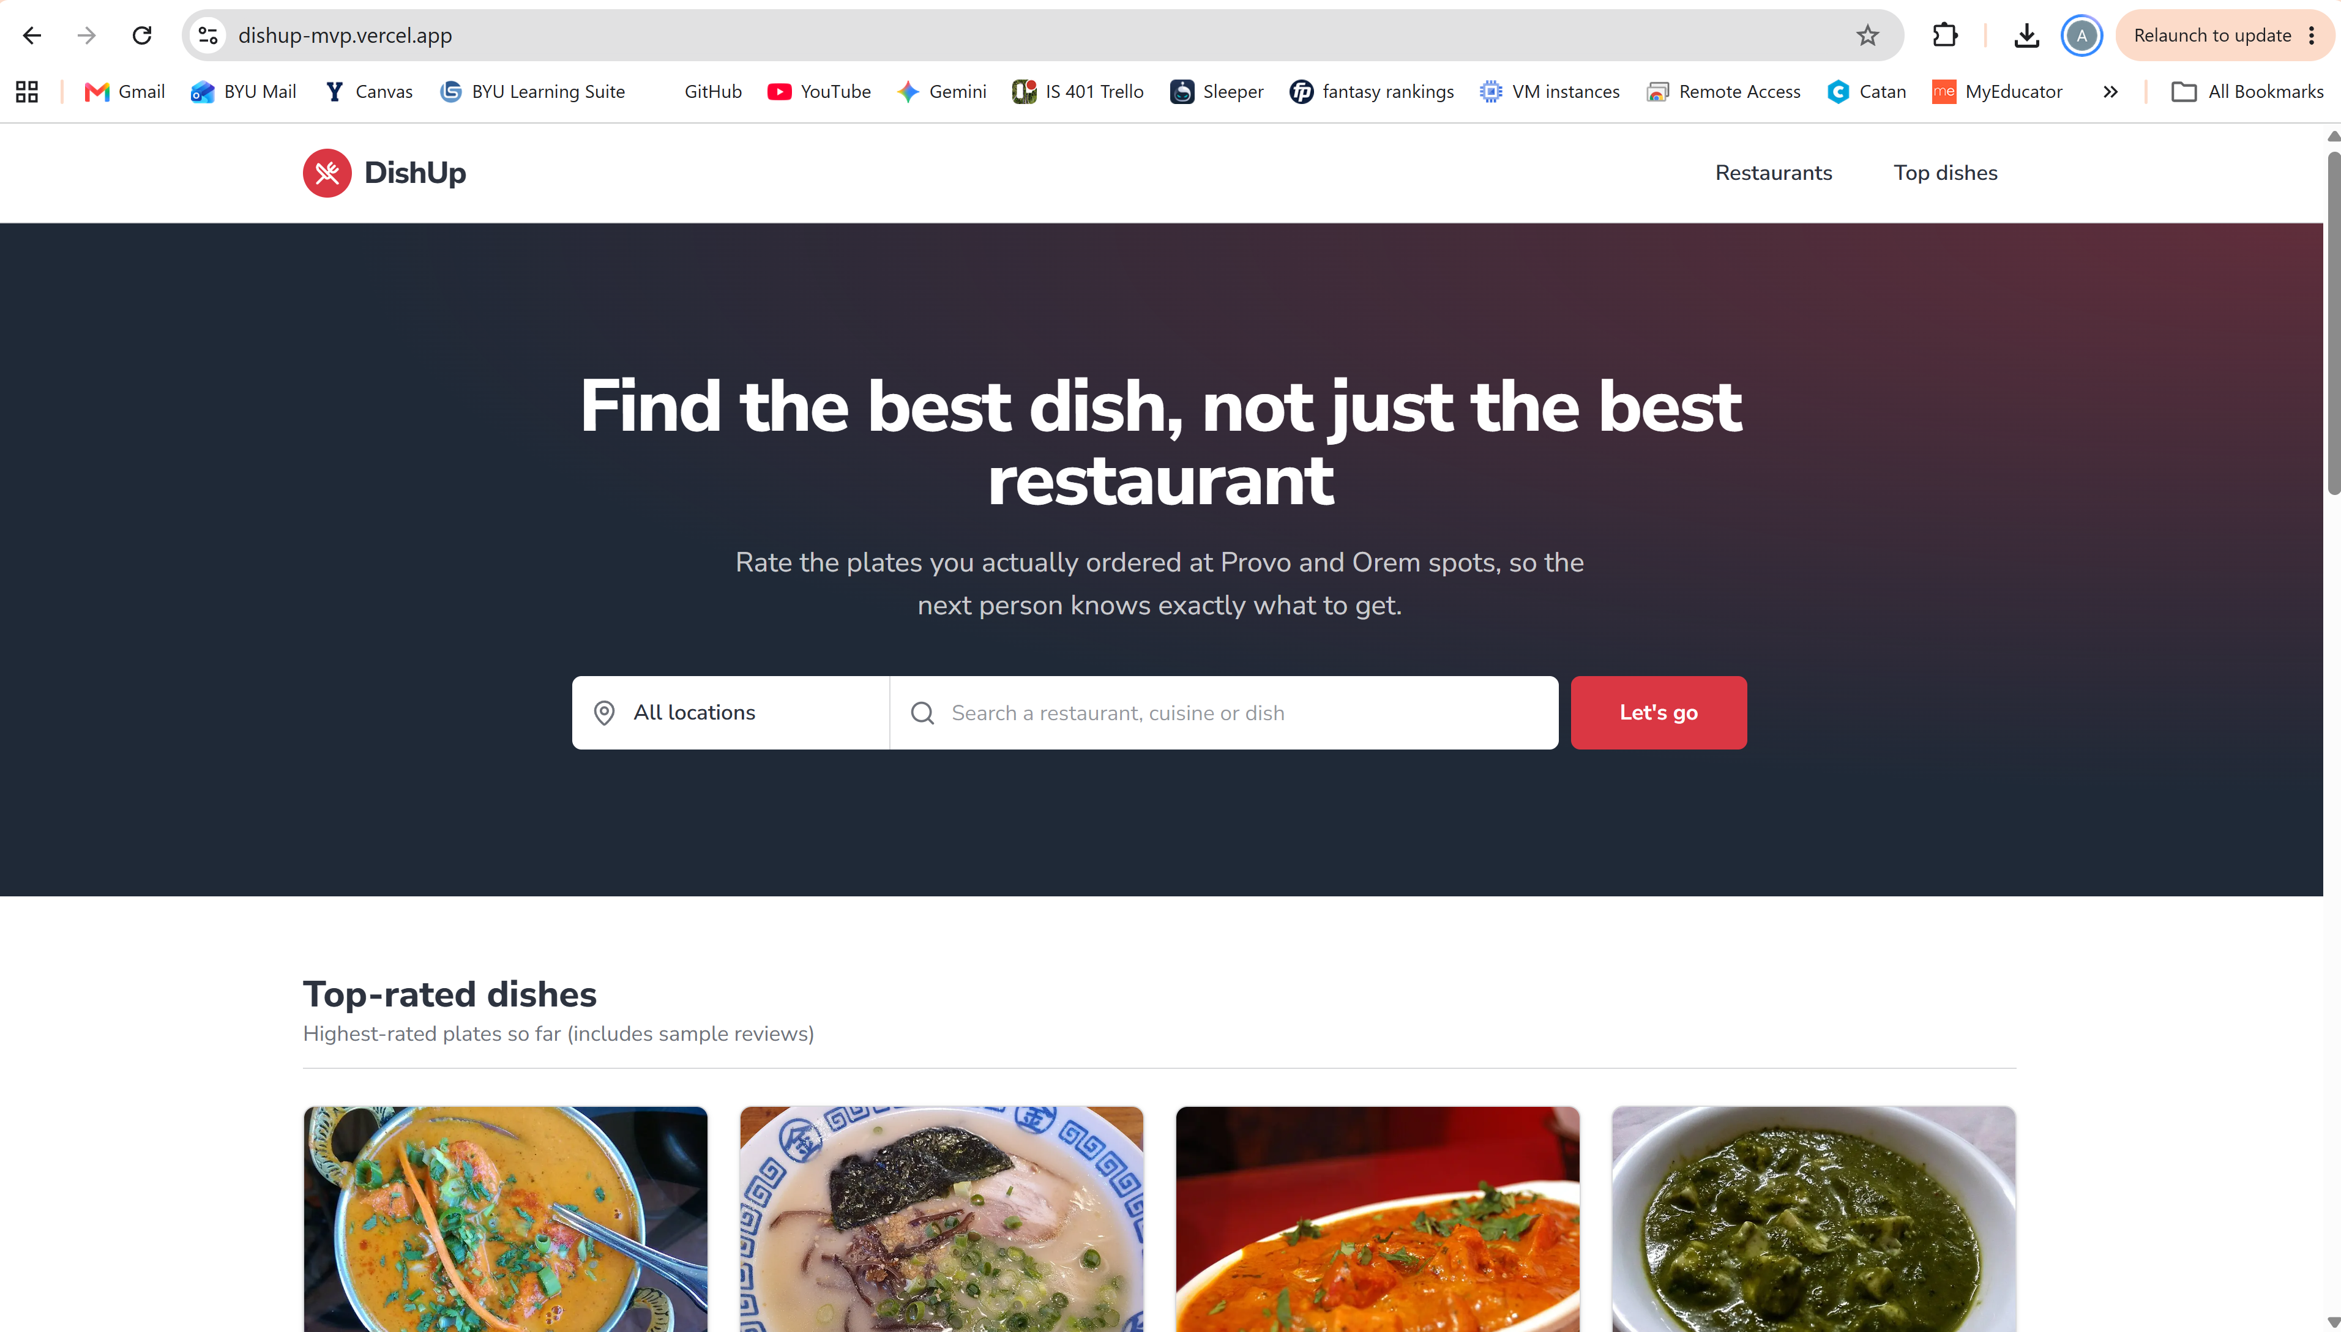
Key Metrics and Results
Metric | Target | Round 1 | Round 2
Testers who post a review without help | ≥ 80% | 4 of 4 | 100% (4/4)
Time to post first review | < 2 min | 1 min average | 1 min average
Searches that return a useful result | ≥ 80% | 8 of 20 (40%) | 17/20 (85%)
Ease of posting a review (1–5) | ≥ 4 | 5 | 5 (4/4 rated 5)
Likely to rate their next meal (7+ of 10) | ≥ 60% | 8 | 75% (3/4)(Average rating of 8.5)
Saw their own review right after posting (new) | ≥ 80% | Not measured | 100% (4/4)
Who I Tested With
4 New BYU students that I didn’t know that I met in the Tanner building that eat out at least once a week. None are friends, family or Round 1 testers. Each did a short session on their own phone: find a dish, post a review, then a short survey.
Learnings
- Search went from 40% to 85% useful (8 of 20 → 17 of 20). Plurals and phrases like "tacos", "indian food" and "korean bbq" now work. The searches that still failed were for cuisines DishUp doesn't have yet (like sushi, Thai, Chinese or breakfast), so the gap is now restaurant coverage, not search.
- Seeing their review fixed the "did it work?" problem. All 4 testers saw their review right after posting (4 of 4), because the page scrolls to it and labels it "Your review".
- A few new rough edges. Searching "mexican" suggests "Did you mean american?". On phones, the sticky "Rate a dish here" button sits right next to the rate card's own button. Searching "tacos" with Orem selected says "Nothing for 'tacos' yet" even though Provo has tacos.
Tweaks
- Add restaurants for the cuisines people search for (Mexican, sushi, breakfast, Chinese, Thai, boba).
- Fix misleading search messages: skip typo suggestions for real cuisine names and show cuisine options instead, and name the city in the empty-state heading ("No tacos in Orem yet").
- Hide the sticky Rate bar once the rate card is on screen, so phones don't show two "Rate a dish here" buttons.

